

Container DB creation steps
Oracle 19c database version

Project



DISCLAIMER

This document is strictly private, confidential and personal to its recipients and should not be copied, distributed or reproduced in whole or in part, nor passed to any third party.

Version history
Date | Version | Description | Author
2021-11-20 | 1.0 | Initial Version | Karthikeyan Saravanan
2021-11-26 | 1.1 | Updated version | Sharang Dwivedi

Contents
Version history 3
1. Introduction 5
2. Prerequisite 5
3. Create container DB 5
4. Post verification 27

Introduction

This document describes the steps to create the container database using dbca utility.

Prerequisite
- Grid and rdbms installation should complete before proceeding
- $ cd /backup/Oracle19c_SW

Create container DB
Set the oracle home
$ export ORACLE_HOME=/u01/app/oracle/rdbms19c
Launch DBCA $ dbca
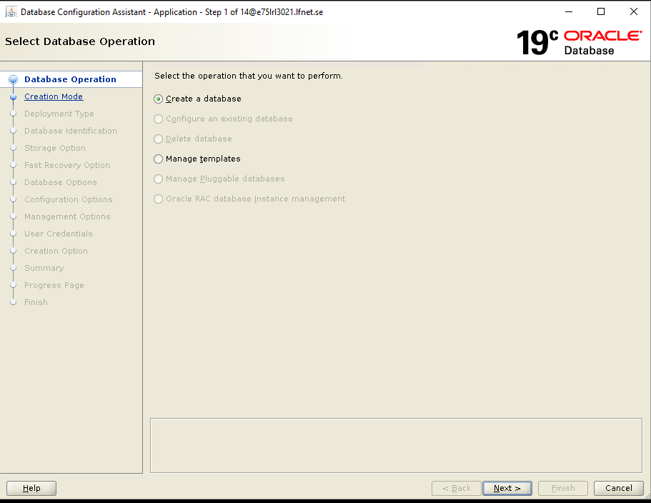
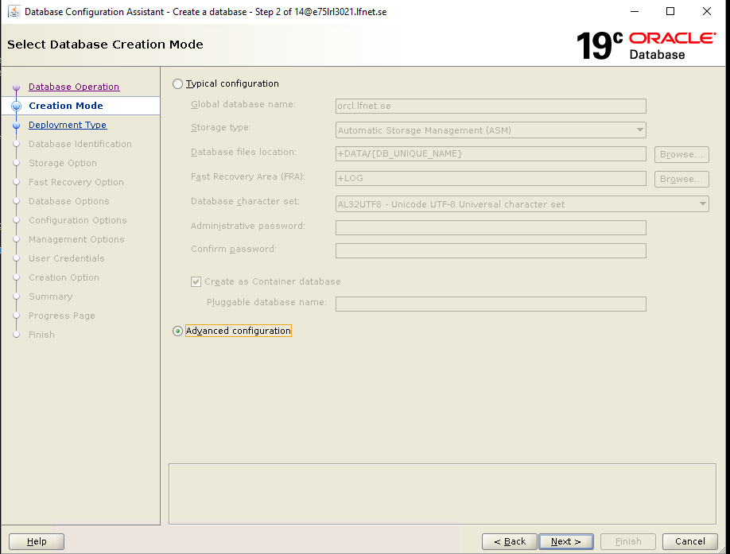
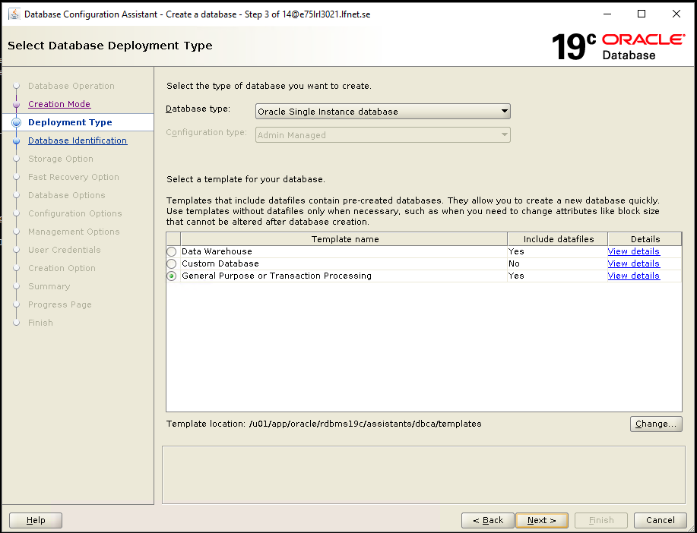
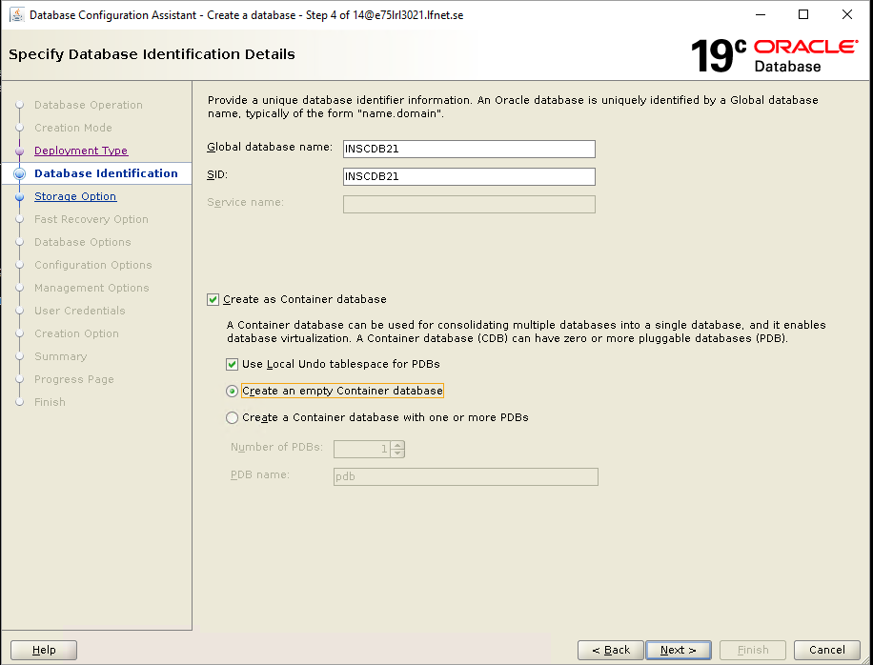
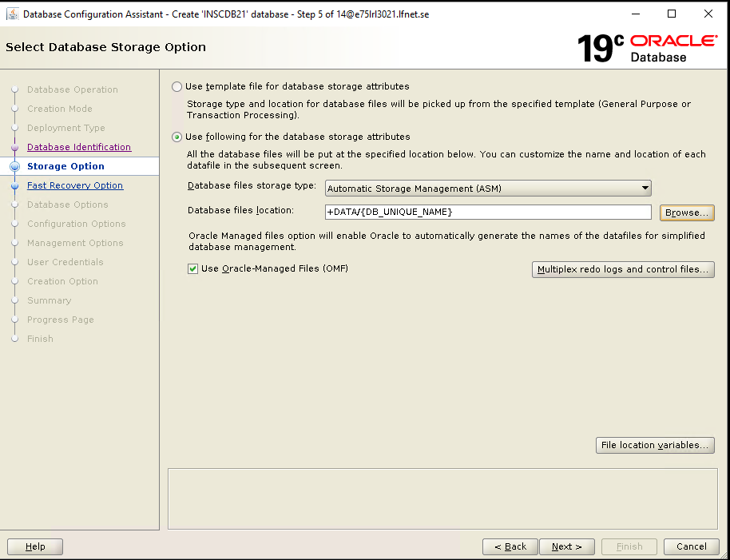
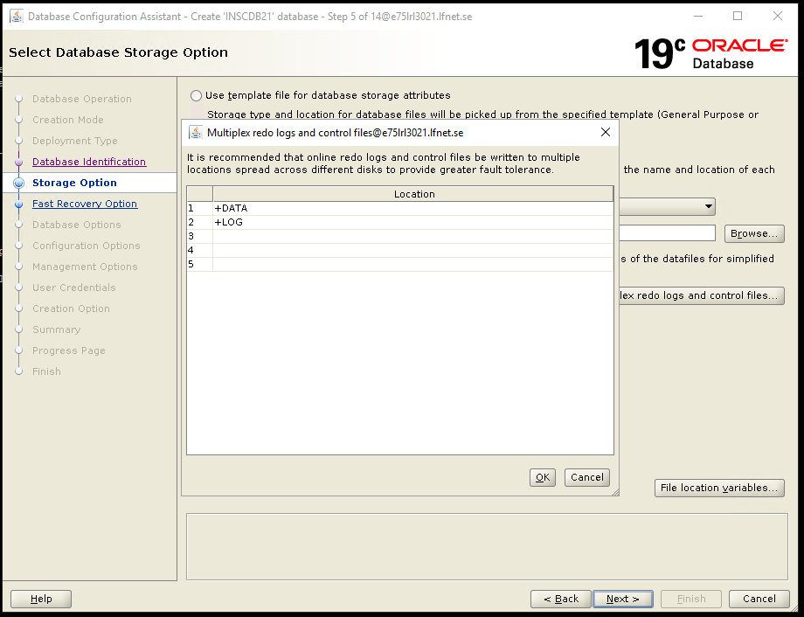

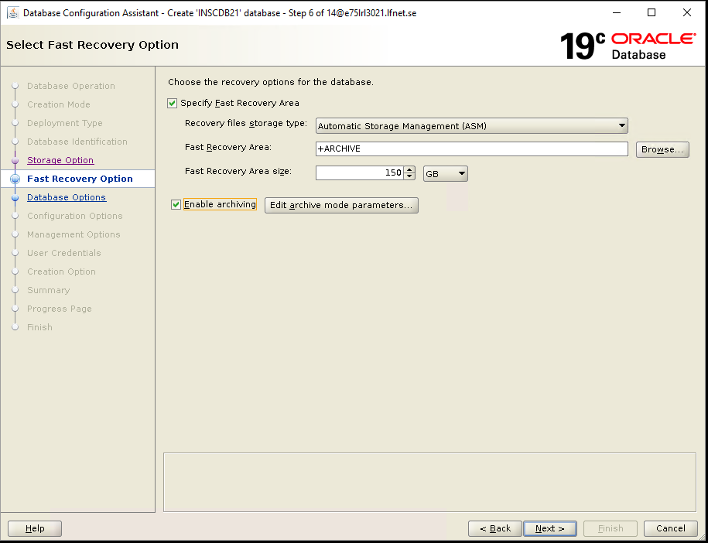
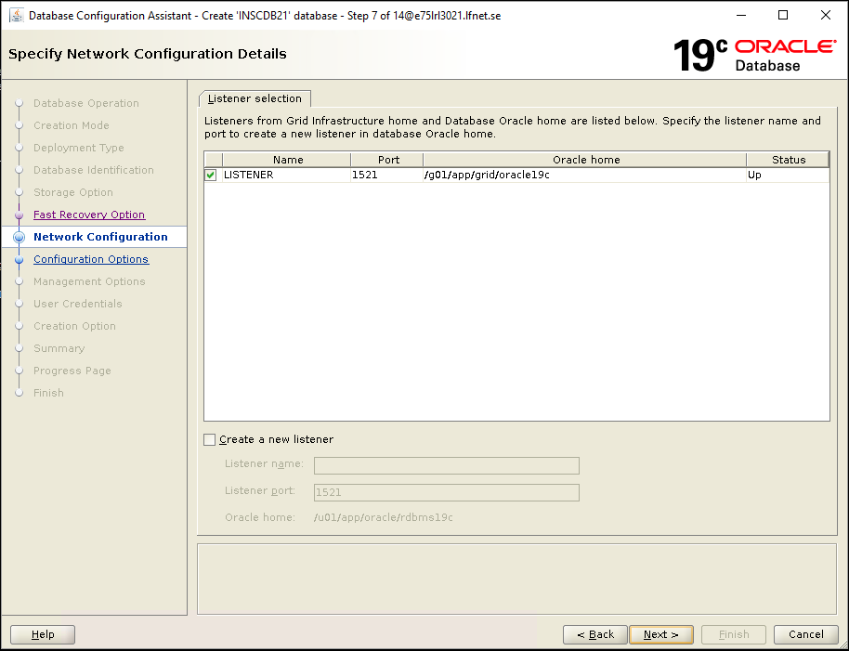
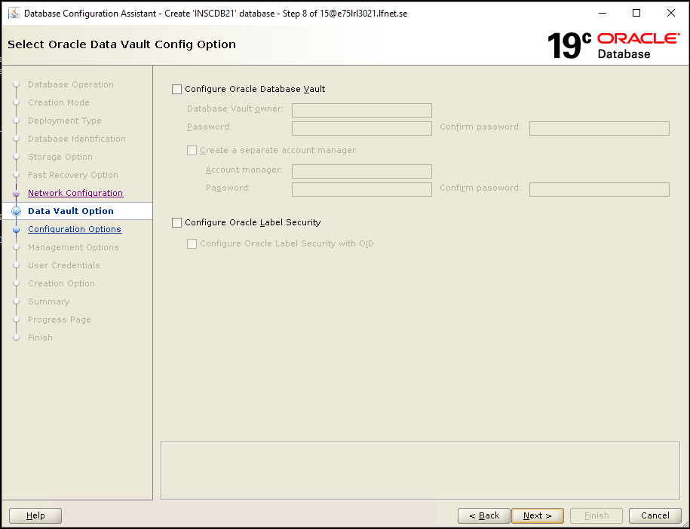
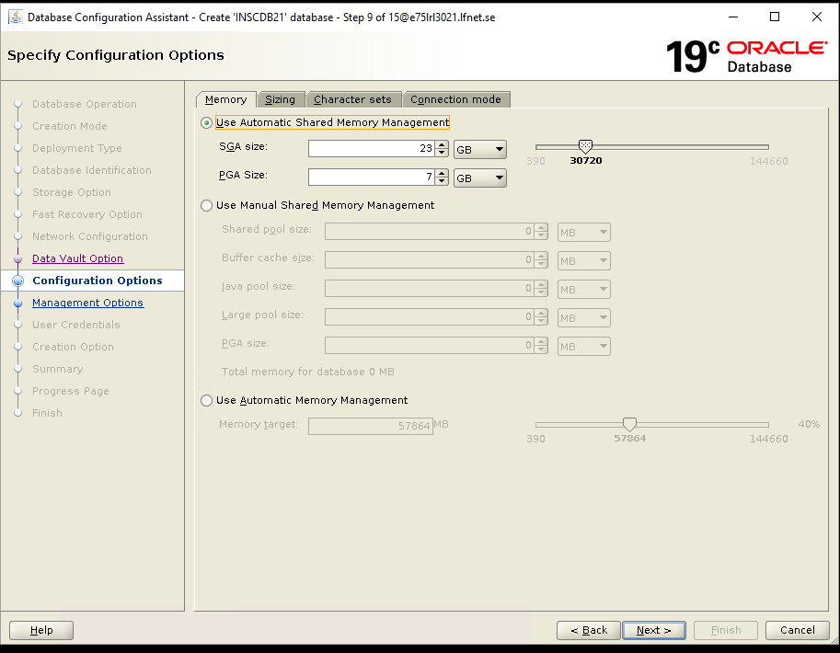
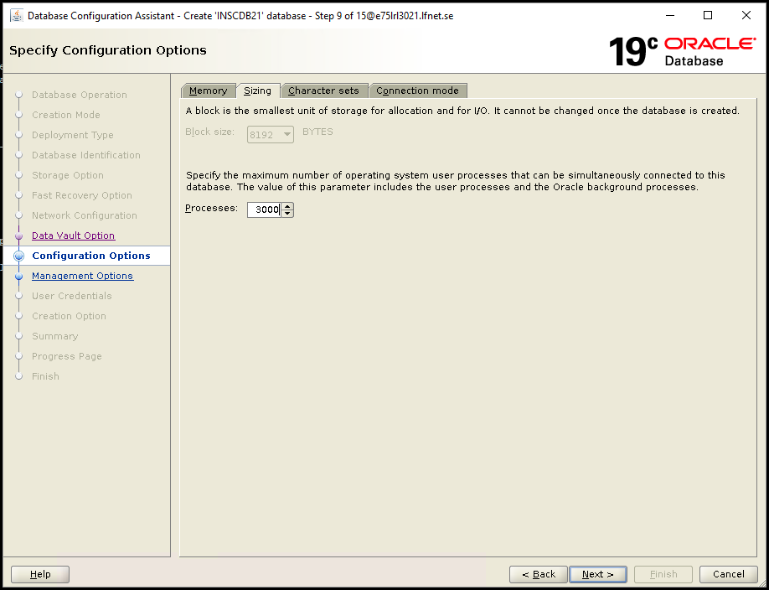
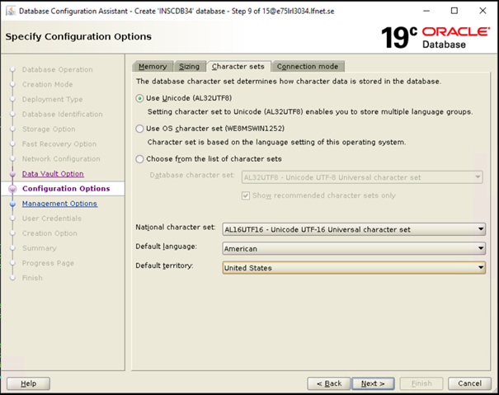
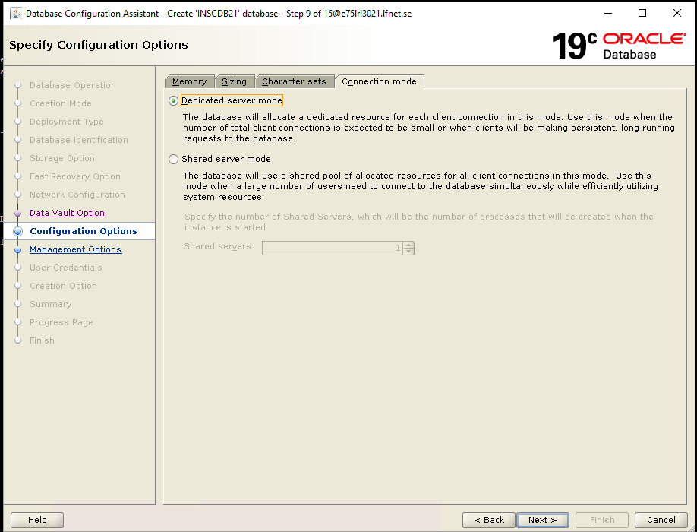
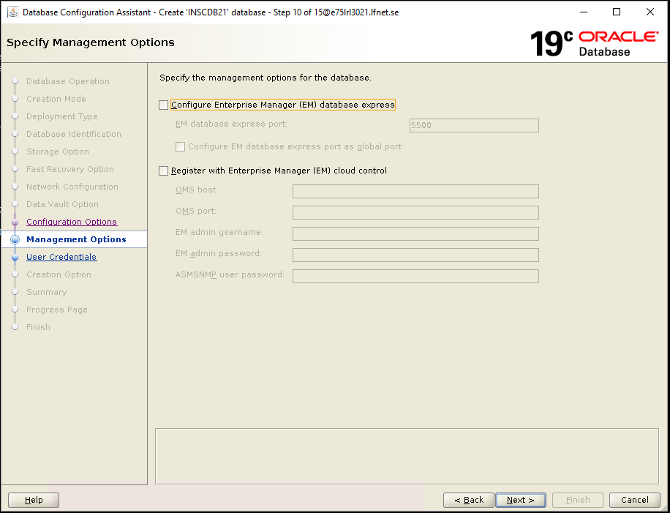
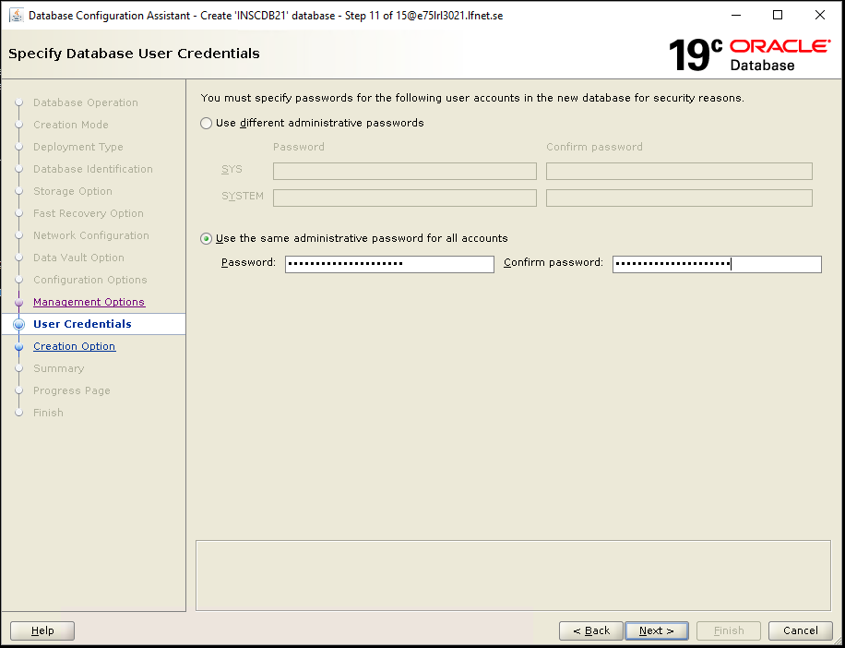
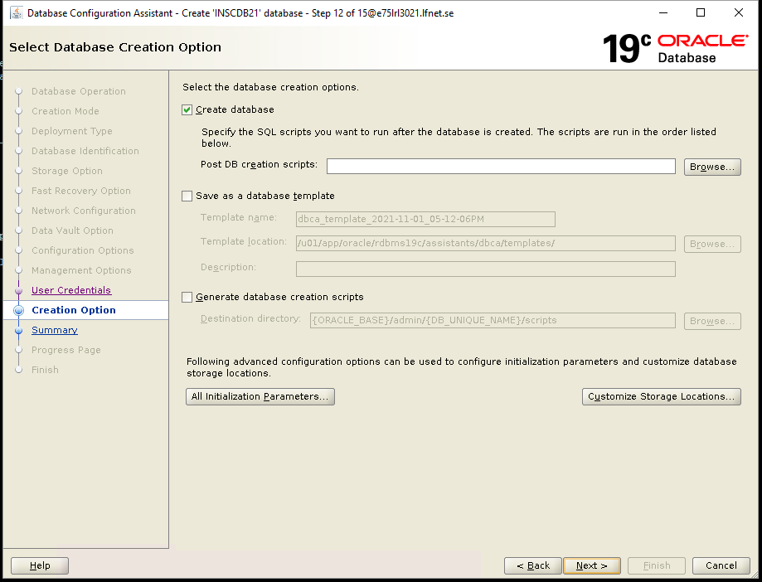
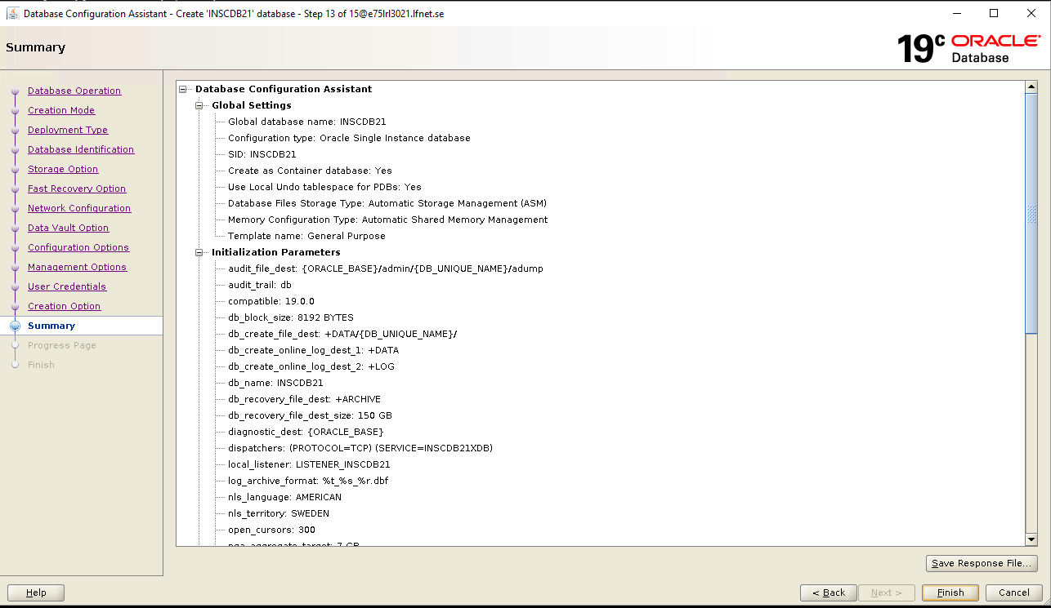
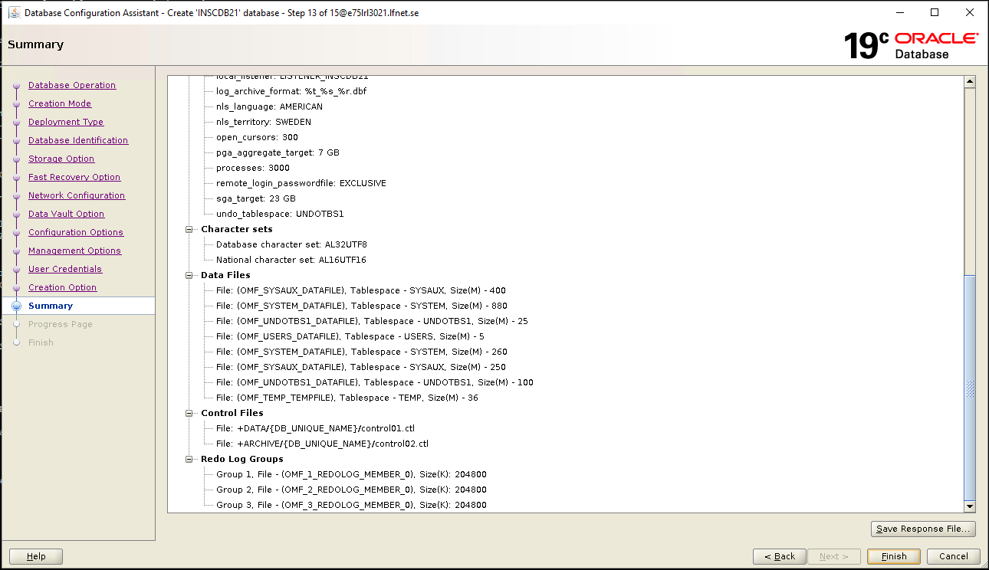
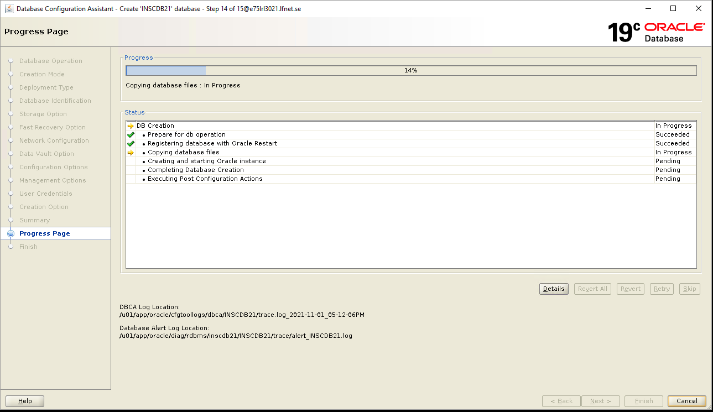
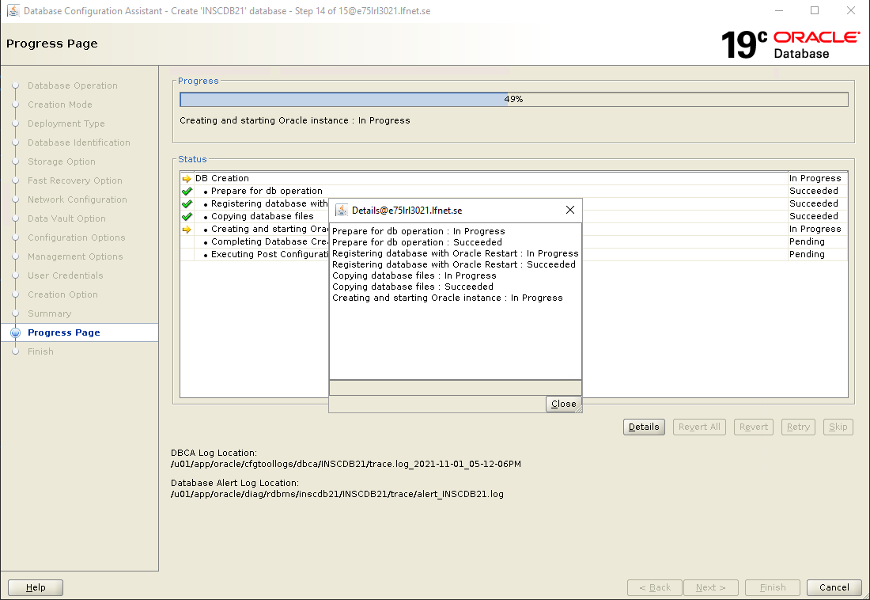
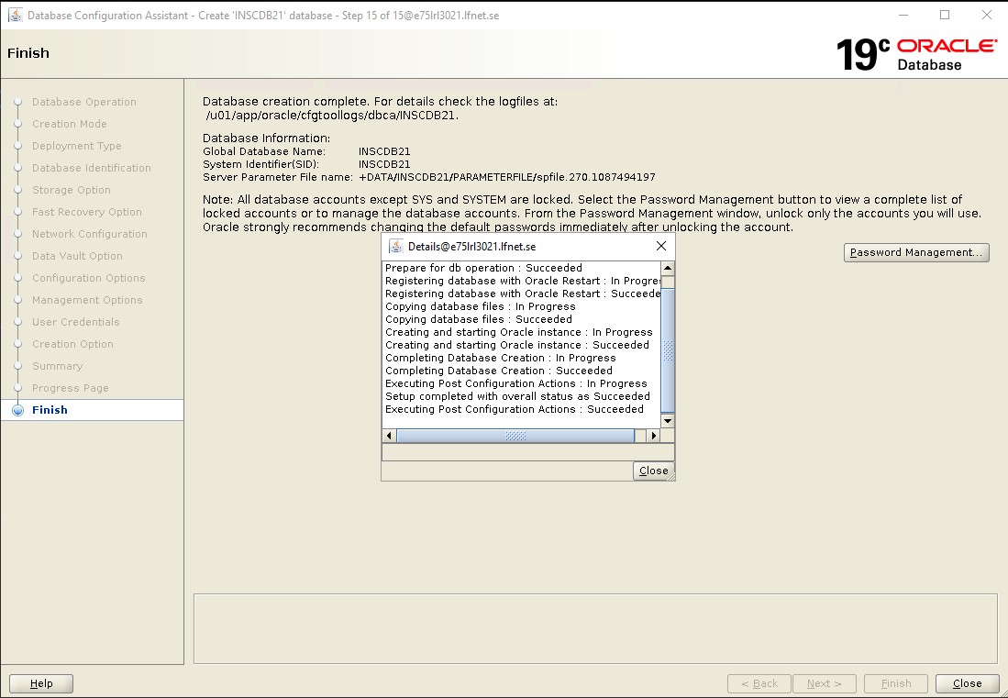
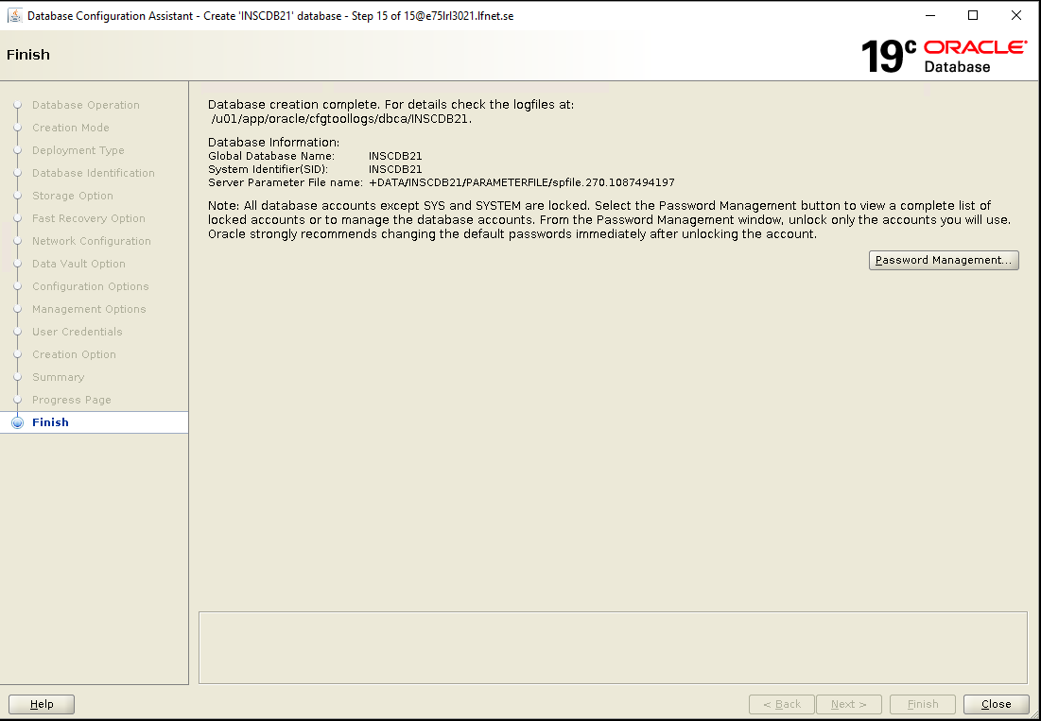
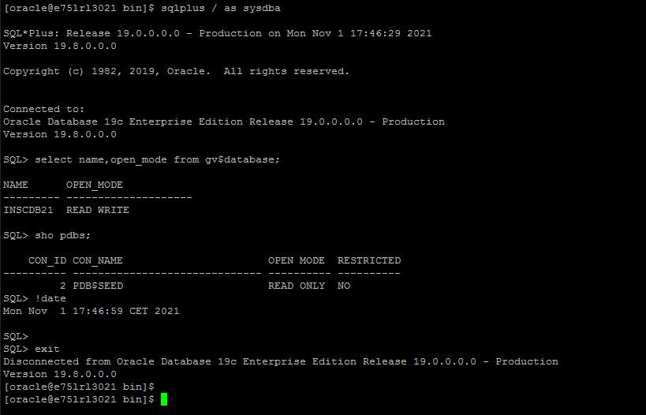

Post verification

Validate the created container DB
SELECT dbid, name, created, log_mode, open_mode, cdb, con_id FROM v$database;
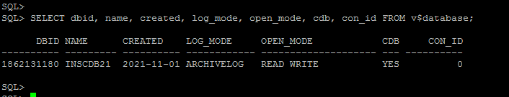
Validate if the seed container database is created

set linesize 400
col OPEN_TIME for a30
col NAME for a20
select con_id, dbid, guid, name, open_mode, restricted, TO_CHAR(open_time, 'DD-MON-YY HH:MI:SS AM') OPEN_TIME from v$containers;

#Validate the database registry

col comp_name for a40
col version for a15
col status for a10
SELECT name, comp_name, version, status FROM v$database, dba_registry;

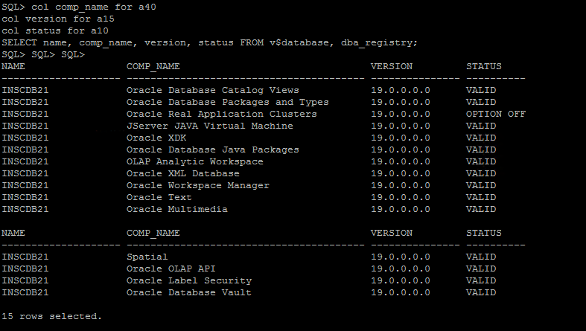

Verify NLS parameters

col VALUE for a25
SELECT * FROM v$nls_parameters WHERE parameter LIKE '%CHARACTERSET%';
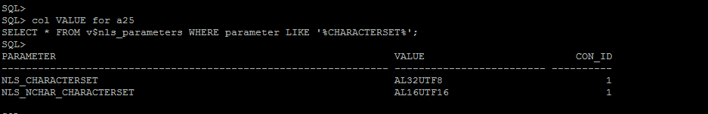
Check redo log files and add 10 redo log groups with 100 mb size each

col MEMBER for a60
SELECT a.group#, a.members, a.bytes/1024/1024 SIZE_MB, a.status, b.member
FROM v$log a, v$logfile b
WHERE a.group# = b.group#;

ALTER DATABASE ADD LOGFILE THREAD 1 GROUP 2('+DATA', '+LOG') SIZE 100m;

Drop and recreate existing redo log group with 100MB size

Alter database drop logfile group 2;
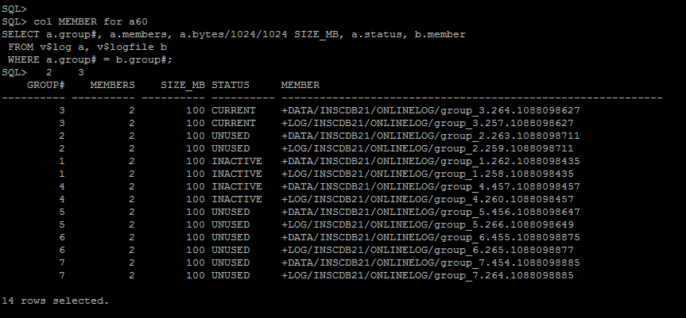
Check the tablespace name, size, status, resize the datafiles and set autoextend off

col DB_NAME for a20
col DATA_FILE_NAME for a60
set linesize 400
set pagesize 9999
SELECT c.name DB_NAME, a.name TABLESPACE_NAME, b.name DATA_FILE_NAME, b.bytes/1024/1024 SIZE_MB, b.status FROM v$tablespace a, v$datafile b, v$containers c
WHERE a.con_id = b.con_id
AND a.con_id = c.con_id
AND a.ts# = b.ts#
ORDER BY a.con_id, a.TS#;

col FILE_NAME for a60
select file_name, autoextensible from dba_data_files;
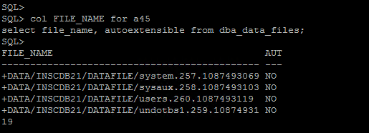
Validate the DB configuration like spfile, password file, oracle home etc
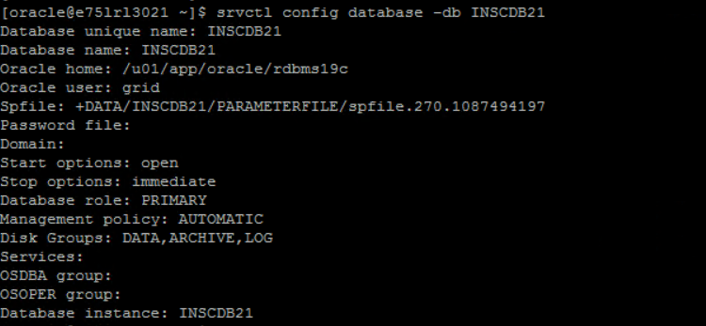

Update below parameter and restart container.
alter system set compatible= '19.8.0' scope=spfile;
alter system set memory_max_target=60G scope=spfile;
alter system set memory_target=50G scope=spfile;
alter system set processes=6000 scope=spfile;
alter system set open_cursors=3000 scope=spfile;
alter system set db_files=1000 scope=spfile;

END OF DOCUMENT

